Login Page ScreenShot:

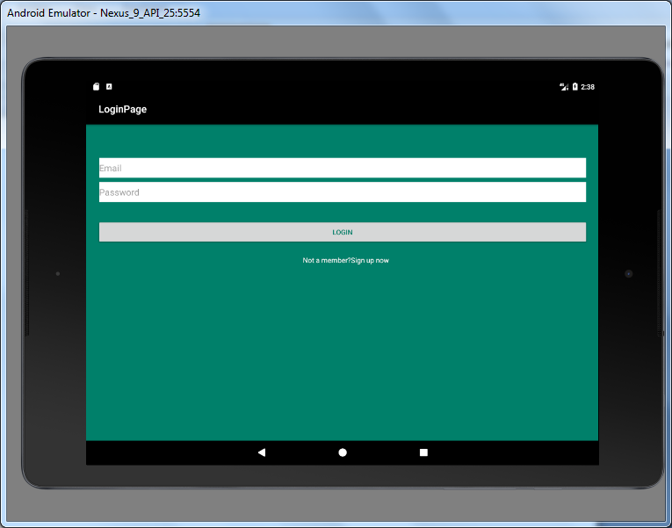

\*The above attached screenshots is from tablet screen